VERIZON WIRELESS

Disparity Map Recruitment Assignment

Assignment:

1. Using the two rectified stereo images below (left and right), calculate a disparity map using one of OpenCV's stereo matching algorithms (e.g. StereoBM).  
     
   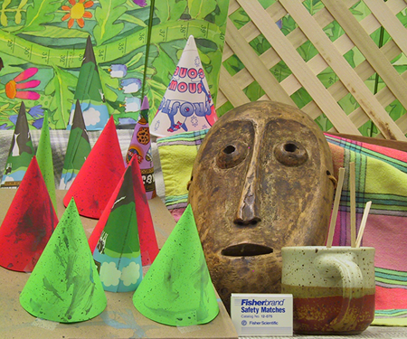 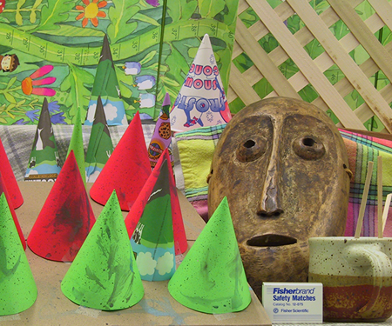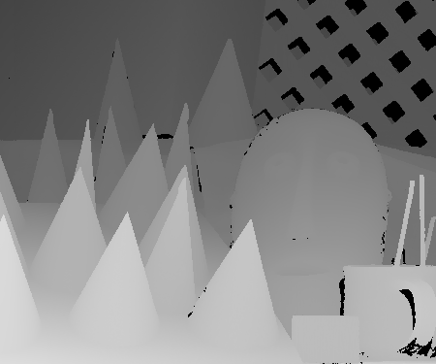  
      
   You can obtain the image files at <http://vision.middlebury.edu/stereo/data/scenes2003/>

Your disparity map values should adhere to the definition in the link above ("Disparities are encoded using a scale factor 4 for gray levels 1 .. 255, while gray level 0 means "unknown disparity". Therefore, the encoded disparity range is 0.25 .. 63.75 pixels.")  
  
You must submit your generated disparity map (png format referred) using a half size or full size resolution as defined in the link above along with your solution code.

1. Using OpenCV camera calibration and 3D reconstruction modules, apply 3D projection transformations to the Disparity Map obrained in part 1 of the assignment to generate a Point Cloud 3D scene (preferably with colors on each point corresponding to colors on the color image pixels). Then use OpenGL to render the 3D point cloud obtained from reprojecting the disparity map. One approach is to use the OpenCV function "reprojectImageTo3D" that takes an input disparity map and outputs 3D points. Since the input images are already rectified you cannot use stereoRectify to derive the Q matrix and must populate the Q matrix parameters yourself. You can find more information by searching "opencv simple Q matrix".  
     
   You must submit your solution code along with screenshots of the rendered 3D point cloud using OpenGL from Front, Left, Top and Offset views and or any other views that show the scene features and proper dimensions.

EXTRA CREDIT

1. For extra credit, use your laptop web cam to take a stereo image pair (by moving your laptop horizontaly a known number of inches). Then, generate a disparity map from your input images. Hint: there are more steps to do this than in part 1 of the assignment.  
     
   You must submit your solution code along with copies of your input images, calibration images and output disparity map.

NOTE: Recorded video of a demo walkthrough of all your working assignments is encouraged.